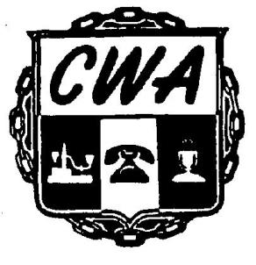
LOCAL 13500
CWA Duquesne Club Bargaining Report #2
October 2, 2025

We are pleased to announce that late on Wednesday, October 1, 2025 we reached Tentative Agreement on our contract negotiations with the Duquesne Club in Pittsburgh.
The next steps are to present this agreement to the CWA members at the Club for review and vote on ratification.
Contract explanation meetings and the ratification vote will be held on Friday, October 3rd at the Omni William Penn Hotel, the Allegheny Room, 17th floor, from 8:00AM to 5:00PM
Your vote is very important. Please make every effort to attend the meeting so we can answer all your questions.
Thank you for all the support you have shown towards the Bargaining Committee.

Your Bargaining Team
Cindy Neumeyer, Local 13500 President
Robin Bingle, Chief Steward
Kathy Short, Local 13500 Executive Secretary - Treasurer
John Petrini, CWA Staff Representative

